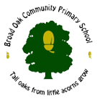
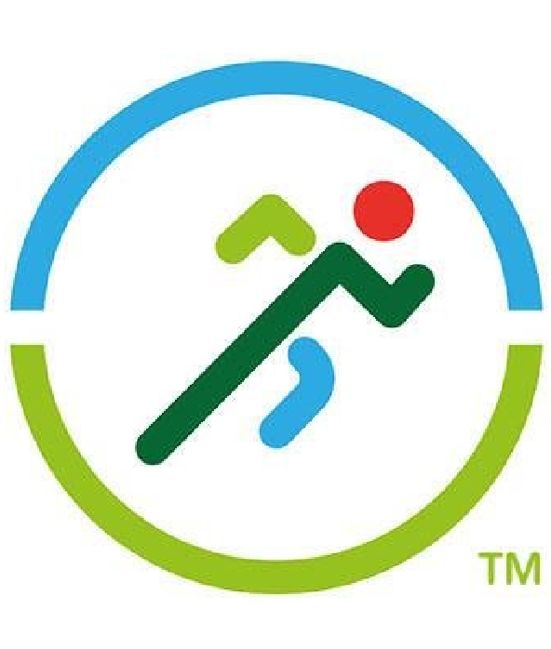
5KM RUNNING AWARD 2021
This is presented to: _________________
for their fantastic achievement of running 5km in a week.

MISS BOWES  Sports Coordinator | MRS HIGNETT  School Headteacher

