Friday 28th January 2021
Adjectives
LO: To label pictures with adjectives.
Look at the following pictures. Different parts have been labelled. For each thing labelled think of and write down an adjective to describe it. On the each I have given an example in red, on the green line underneath try and think of a different one of your own and write it down.
Grass
example – long
___________________________
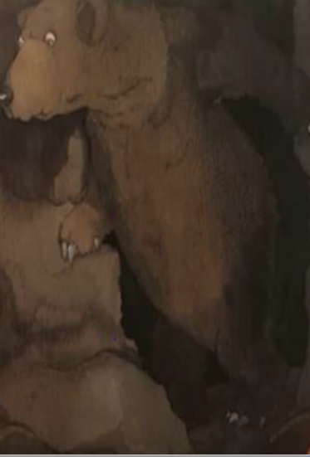
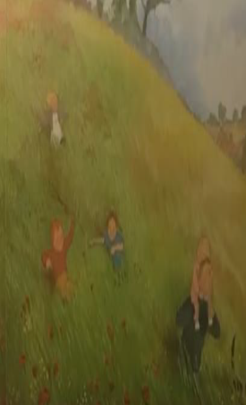
Claws
example – long
___________________________
Fur
example – brown
___________________________
Eyes
example – huge
___________________________
Dad
example – tall
___________________________
Child
example – small
___________________________

