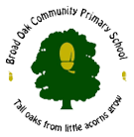

Ending

Monday 18th January 2021

Speech/Quotes

Caption

Picture

Introduction

Heading

**The Broad Oak Times**