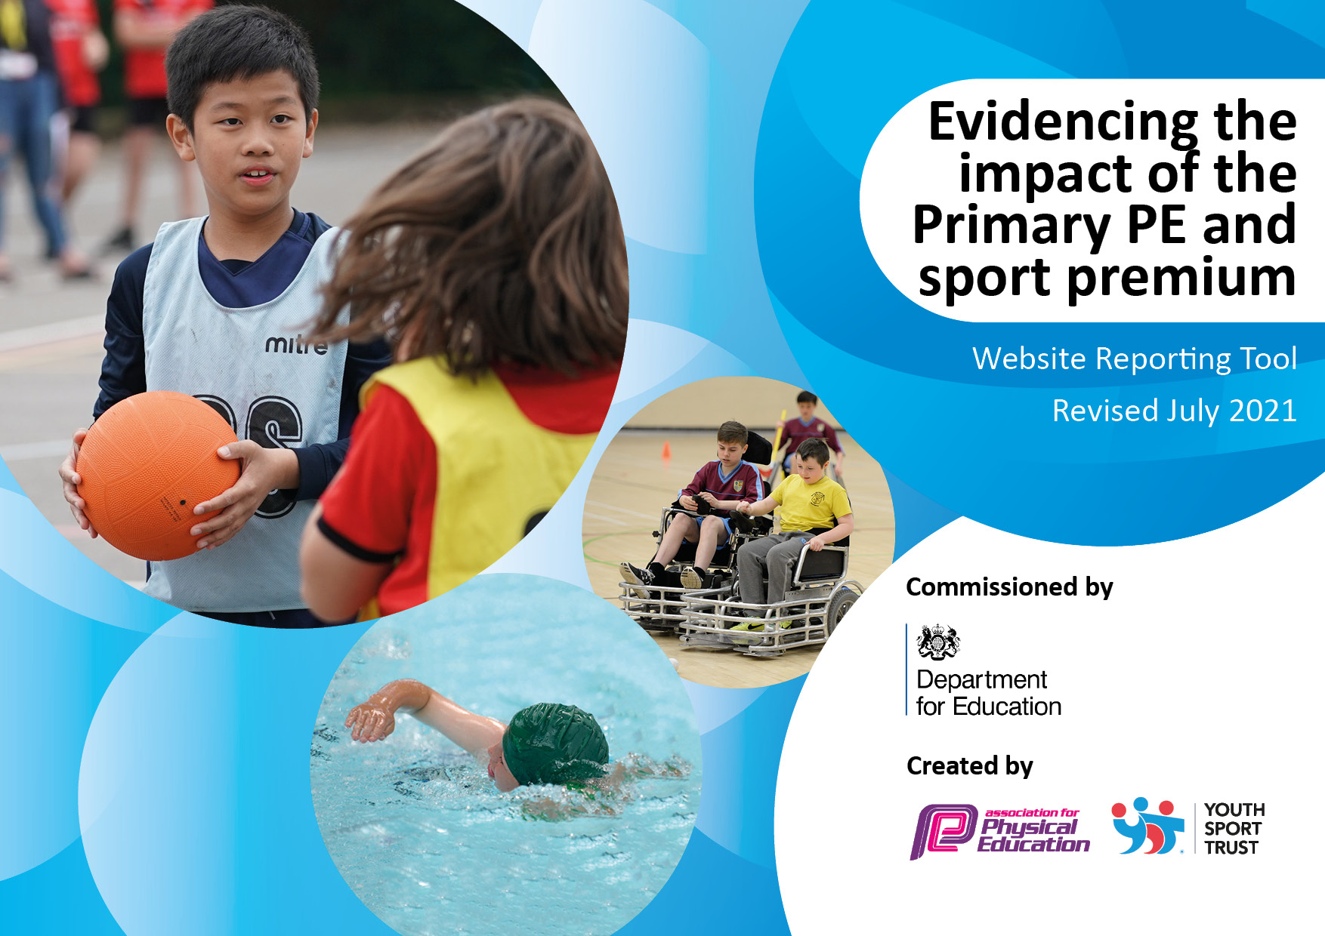
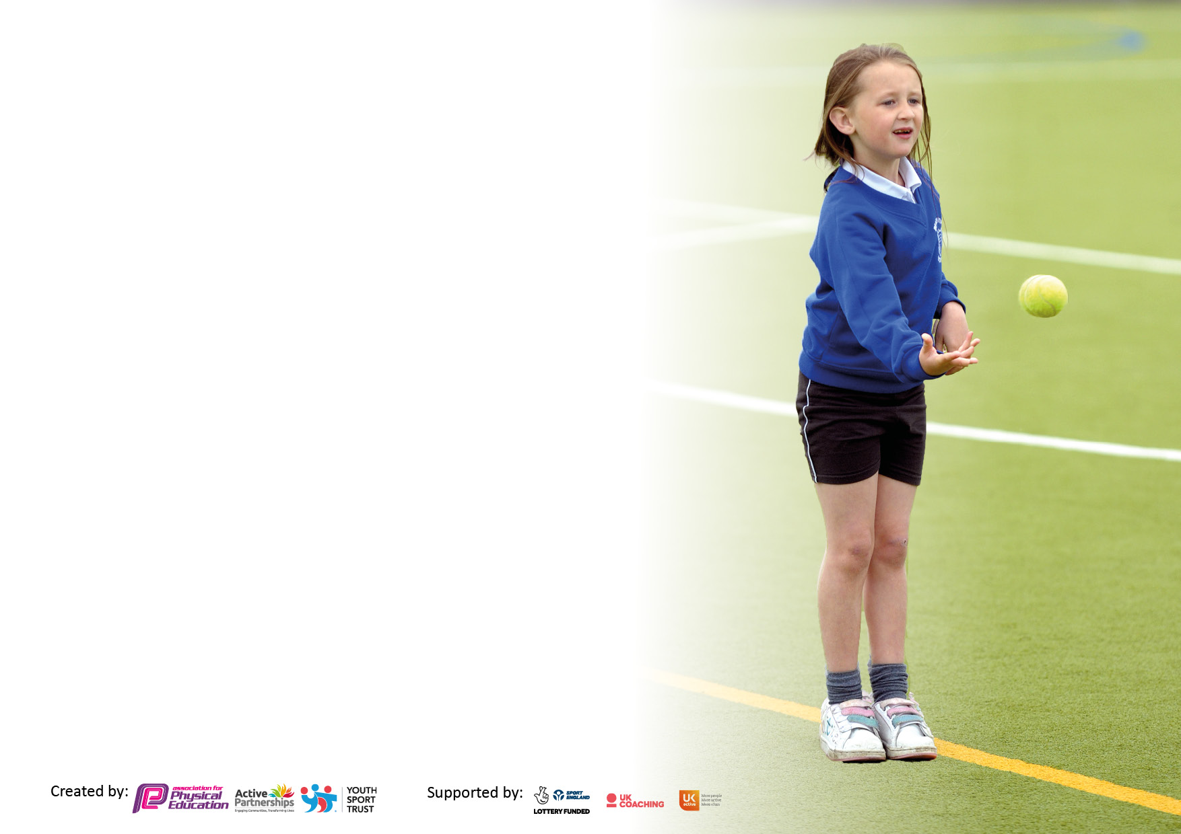

It is important that your grant is used effectively and based on school need. The Education Inspection Framework makes clear there will be a focus on ‘whether leaders and those responsible for governors all understand their respective roles and perform these in a way that enhances the effectiveness of the school’.

Under the Quality of Education Ofsted inspectors consider:
Intent - Curriculum design, coverage and appropriateness
Implementation - Curriculum delivery, Teaching (pedagogy) and Assessment
Impact - Attainment and progress

To assist schools with common transferable language this template has been developed to utilise the same three headings which should make your plans easily transferable between working documents.

Schools must use the funding to make additional and sustainable improvements to the quality of Physical Education, School Sport and Physical Activity (PESSPA) they offer. This means that you should use the Primary PE and sport premium to:

- Develop or add to the PESSPA activities that your school already offer
- Build capacity and capability within the school to ensure that improvements made now will benefit pupils joining the school in future years
- The Primary PE and sport premium should not be used to fund capital spend projects; the school’s budget should fund these.

Pleasevisitgov.ukfortherevisedDfEguidanceincludingthe5keyindicatorsacrosswhichschoolsshoulddemonstrate animprovement.Thisdocumentwillhelpyoutoreviewyourprovisionandtoreportyourspend.DfEencouragesschools to use this template as an effective way of meeting the reporting requirements of the Primary PE and sport premium.

We recommend you start by reflecting on the impact of current provision and reviewing the previous spend.

Schools are required to publish details of how they spend this funding, including any under-spend from 2019/2020, as well as on the impact it has on pupils’ PE and sport participation and attainment. All funding must be spent by 31st July 2022.

We recommend regularly updating the table and publishing it on your website throughout the year. This evidences your ongoing self-evaluation of how you are using the funding to secure maximum, sustainable impact. Final copy must be posted on your website by the end of the academic year and no later than the 31st July 2021. To see an example of how to complete the table please click HERE.

Details with regard to funding
Please complete the table below.

Total amount carried over from 2019/20 | £2601
Total amount allocated for 2020/21 | £19,890
How much (if any) do you intend to carry over from this total fund into 2021/22? | £1478
Total amount allocated for 2021/22 | £ 12,145
Total amount of funding for 2021/22. To be spent and reported on by 31st July 2022. | £13,623  THIS IS FROM SEPTEMBER-MARCH ONLY
Swimming Data
Please report on your Swimming Data below.

Meeting national curriculum requirements for swimming and water safety.

N.B. Complete this section to your best ability. For example you might have practised safe self-rescue techniques on dry land which you can then transfer to the pool when school swimming restarts.
Due to exceptional circumstances priority should be given to ensuring that pupils can perform safe self rescue even if they do not fully meet the first two requirements of the NC programme of study
What percentage of your current Year 6 cohort swim competently, confidently and proficiently over a distance of at least 25 metres?  N.B. Even though your pupils may swim in another year please report on their attainment on leaving primary school at the end of the summer term 2020.  Please see note above | %
What percentage of your current Year 6 cohort use a range of strokes effectively [for example, front crawl, backstroke and breaststroke]?  Please see note above | %
What percentage of your current Year 6 cohort perform safe self-rescue in different water-based situations? | %
Schools can choose to use the Primary PE and sport premium to provide additional provision for swimming but this must be for activity over and above the national curriculum requirements. Have you used it in this way? | Yes/No

Action Plan and Budget Tracking
Capture your intended annual spend against the 5 key indicators. Clarify the success criteria and evidence of impact that you intend to measure to evaluate for pupils today and for the future.

Academic Year: 2020/21 | Total fund allocated:13,623 | Date Updated:
Key indicator 1: The engagement of all pupils in regular physical activity – Chief Medical Officers guidelines recommend that primary school pupils undertake at least 30 minutes of physical activity a day in school |  |  |  | Percentage of total allocation:
 |  |  |  | %
Intent | Implementation |  | Impact
Your school focus should be clear what you want the pupils to know and be able to do and about  what they need to learn and to  consolidate through practice: | Make sure your actions to achieve are linked to your intentions: | Funding allocated: | Evidence of impact: what do pupils now know and what can they now do? What has changed?: | Sustainability and suggested next steps:
To ensure the engagement of all pupils in regular physical activity – kickstarting healthy active lifestyles and the improvement of the health of all children in school.  To ensure that children are kept active during breaks and lunches and in classes between lessons  To implement whole school fitness challenges to ensure children’s fitness levels are raised, engagement in sport is at a high level and focus in class is maintained/ improved. Daily Mile initiative- 15 mins running/ walking per day (coupled with PE lessons, 45 minutes exercise at lunch time and 15 minutes morning break)  Additional 15 minutes afternoon break given to KS1 children.  Provide children across KS1 and 2 with the opportunity to engage in less common sports such as judo, yoga and archery. | PE lessons timetabled for entire school to ensure sufficient time and coverage.  Specialist PE coach employed to deliver sessions alongside teacher as CPD opportunity.  Provide appropriate and engaging sports equipment for children to use during breaktimes. This will ensure high levels of activity and also promote good behaviour as time will be more structured.  Install Daily Mile Track to provide class teachers with designated area for the children to use.  Judo, yoga and archery sessions organised for children across KS1 and 2.  To date: yoga year 1 and 2, judo year 3, archery year 4 | £ £8465  PEco Schools  (Healthy Active lifestyles)  £500 per term (total of £1500) allocated for equipment across school.  £1350 Enquiry made with Active Mile Daily Track Installers | Best School Golden Mile Installation  Archery £1080  18 sessions  Judo £468  18 sessions  Yoga £1665  37 sessions  £3213
Key indicator 2: The profile of PESSPA being raised across the school as a tool for whole school improvement |  |  |  | Percentage of total allocation:
 |  |  |  | %
Intent | Implementation |  | Impact
Your school focus should be clear what you want the pupils to know and be able to do and about  what they need to learn and to  consolidate through practice: | Make sure your actions to achieve are linked to your intentions: | Funding allocated: | Evidence of impact: what do pupils now know and what can they now do? What has changed?: | Sustainability and suggested next steps:
To use PE and sport as a driver to improve behaviour, attainment and attendance and contribute to the school ethos.  Encouraging children to: Positively challenge themselves and consider how that what they say or do can impact positively or negatively on others.  Encourage positivity and a ‘can do attitude’ within students. Learning how to speak to each other confidently can break many personal boundaries whilst reinforcing confidence and self worth  To use PE as a means to support emotional well-being.  To raise the profile of PE and sport across school and in the community | Military Style Team Building in Schools / Military Obstacle Course & Outdoor Activities Preston & Chorley | OzoneFit  Enquiry made with above company  Yoga sessions arranged for target year groups to encourage and support emotional wellbeing.  Yoga arranged for Y1 &2.  - made very visible in KS2 showcasing all intra school sporting competitions  Taking place that term  - Medals, stickers and scratch card rewards given out regularly in PE lessons to motivate children and engage reluctant participants  - Sporting achievements celebrated in school via school website/ virtual assemblies etc.  - Both staff AND children are commended for their efforts in whole school challenges – through virtual assemblies and remote learning platforms/ emails home/ marvellous me.  - Children encouraged to compete in SHAPES competitions online but also smaller inter-school competitions arranged by staff and external coaches in school. | £  £950  SHAPES enhanced membership

Key indicator 3: Increased confidence, knowledge and skills of all staff in teaching PE and sport |  |  |  | Percentage of total allocation:
 |  |  |  | %
Intent | Implementation |  | Impact
Your school focus should be clear | Make sure your actions to | Funding | Evidence of impact: what do | Sustainability and suggested
what you want the pupils to know | achieve are linked to your | allocated: | pupils now know and what | next steps:
and be able to do and about | intentions: |  | can they now do? What has
what they need to learn and to |  |  | changed?:
consolidate through practice:
To ensure staff are confident in their ability to deliver quality first teaching in PE.  To attend borough wide CPD opportunities  To ensure progression of skills throughout KS1 and 2. | Each staff member to benefit from PE specialist coaching sessions from 2 half terms per year. This will ensure staff can team teach with PEco Schools coach as a form of CPD.  PE Coordinator to make all staff aware of relevant CPD offered through SHAPES enhanced membership and signpost staff to relevant courses e.g. EYFS staff directed to early years CPD.  All staff are aware of the progression of skills map that has been produced by the curriculum lead and this ensured skills progression across KS1 and 2.  REAL PE scheme as a potential new scheme to use across school (planning from EYFS-Y6 available) | *PEco Schools Funding allocation accounted for above*  *SHAPES membership Funding allocated above*  Primary PE Schemes of Work - real PE | Jasmine (jasmineactive.com)  £2290  1 year membership
Key indicator 4: Broader experience of a range of sports and activities offered to all pupils |  |  |  | Percentage of total allocation:
Intent | Implementation |  | Impact
Your school focus should be clear | Make sure your actions to | Funding | Evidence of impact: what do | Sustainability and suggested
what you want the pupils to know | achieve are linked to your | allocated: | pupils now know and what | next steps:
and be able to do and about | intentions: |  | can they now do? What has
what they need to learn and to |  |  | changed?:
consolidate through practice:
To Increase opportunities for participation in sport for ALL our children regardless of age, ethnicity, gender or level of performance.  To enhance the range and quantity of curricular sporting activities on offer to all children | Arrange a diverse range of sporting activities to be delivered by specialist teachers throughout the year e.g. archery, judo, dance gymnastics, rugby, football etc.  PEco Schools coach has delivered the  following sports this year . These have been delivered during curriculum time as all extra-curricular activities have been put on hold this year so far.  Football  Netball  Benchball  Dodgeball  Multiskills  Athletics  Hockey  running  circuit training | Yoga, Judo and archery  Funding allocated above*  *PEco Schools Funding allocation accounted for above*

Key indicator 5: Increased participation in competitive sport |  |  |  | Percentage of total allocation:
 |  |  |  | %
Intent | Implementation |  | Impact
Your school focus should be clear | Make sure your actions to | Funding | Evidence of impact: what do | Sustainability and suggested
what you want the pupils to know | achieve are linked to your | allocated: | pupils now know and what | next steps:
and be able to do and about | intentions: |  | can they now do? What has
what they need to learn and to |  |  | changed?:
consolidate through practice:
To develop opportunities for whole school competition and intra school sports competitions  To compete in SHAPES organised inter school competitions. | Intra school competitions organised by sports provided PEco schools. These run throughout the year and are celebrated via virtual assemblies and through school leader board.  Entry into SHAPES competitions completed for a variety of competitions to date: Girls football, Y5 Football, dodgeball, boccia for autumn term. | *SHAPES membership funding allocated above*

Signed off by
Head Teacher:
Date:
Subject Leader:
Date:
Governor:
Date:

