Text – The Day the Crayons Quit
Vocabulary
Q1. V – What is an outline?
Q2. V – Why does green crayon use the word ‘career’?
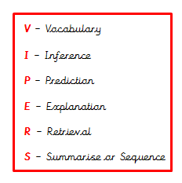
Q3. V – What does ‘stubby’ mean?
Q4. V – Define ‘unused’.

