https://www.mapsofworld.com/united-kingdom/cities-map.html
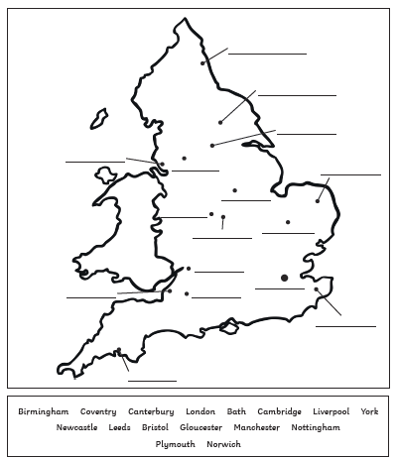
Y6 Geography Map Work Activity: Use the website above to look at a map of the UK. All the major cities are labelled. Focus on England – can you locate where these cities in England are and make a list labelling where they should go on the map below?
16.
15.
14.
13.
12.
11.
10.
9.
8.
7.
6.
5.
4.
3.
2.
1.

