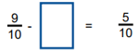
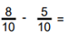
Complete the fractions calculations in your home learning maths book.
1. 2.
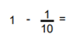
3. 4.
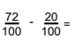
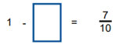
5. 6.
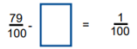
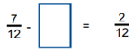
7. 8.

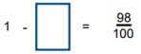
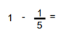
9. 10.

