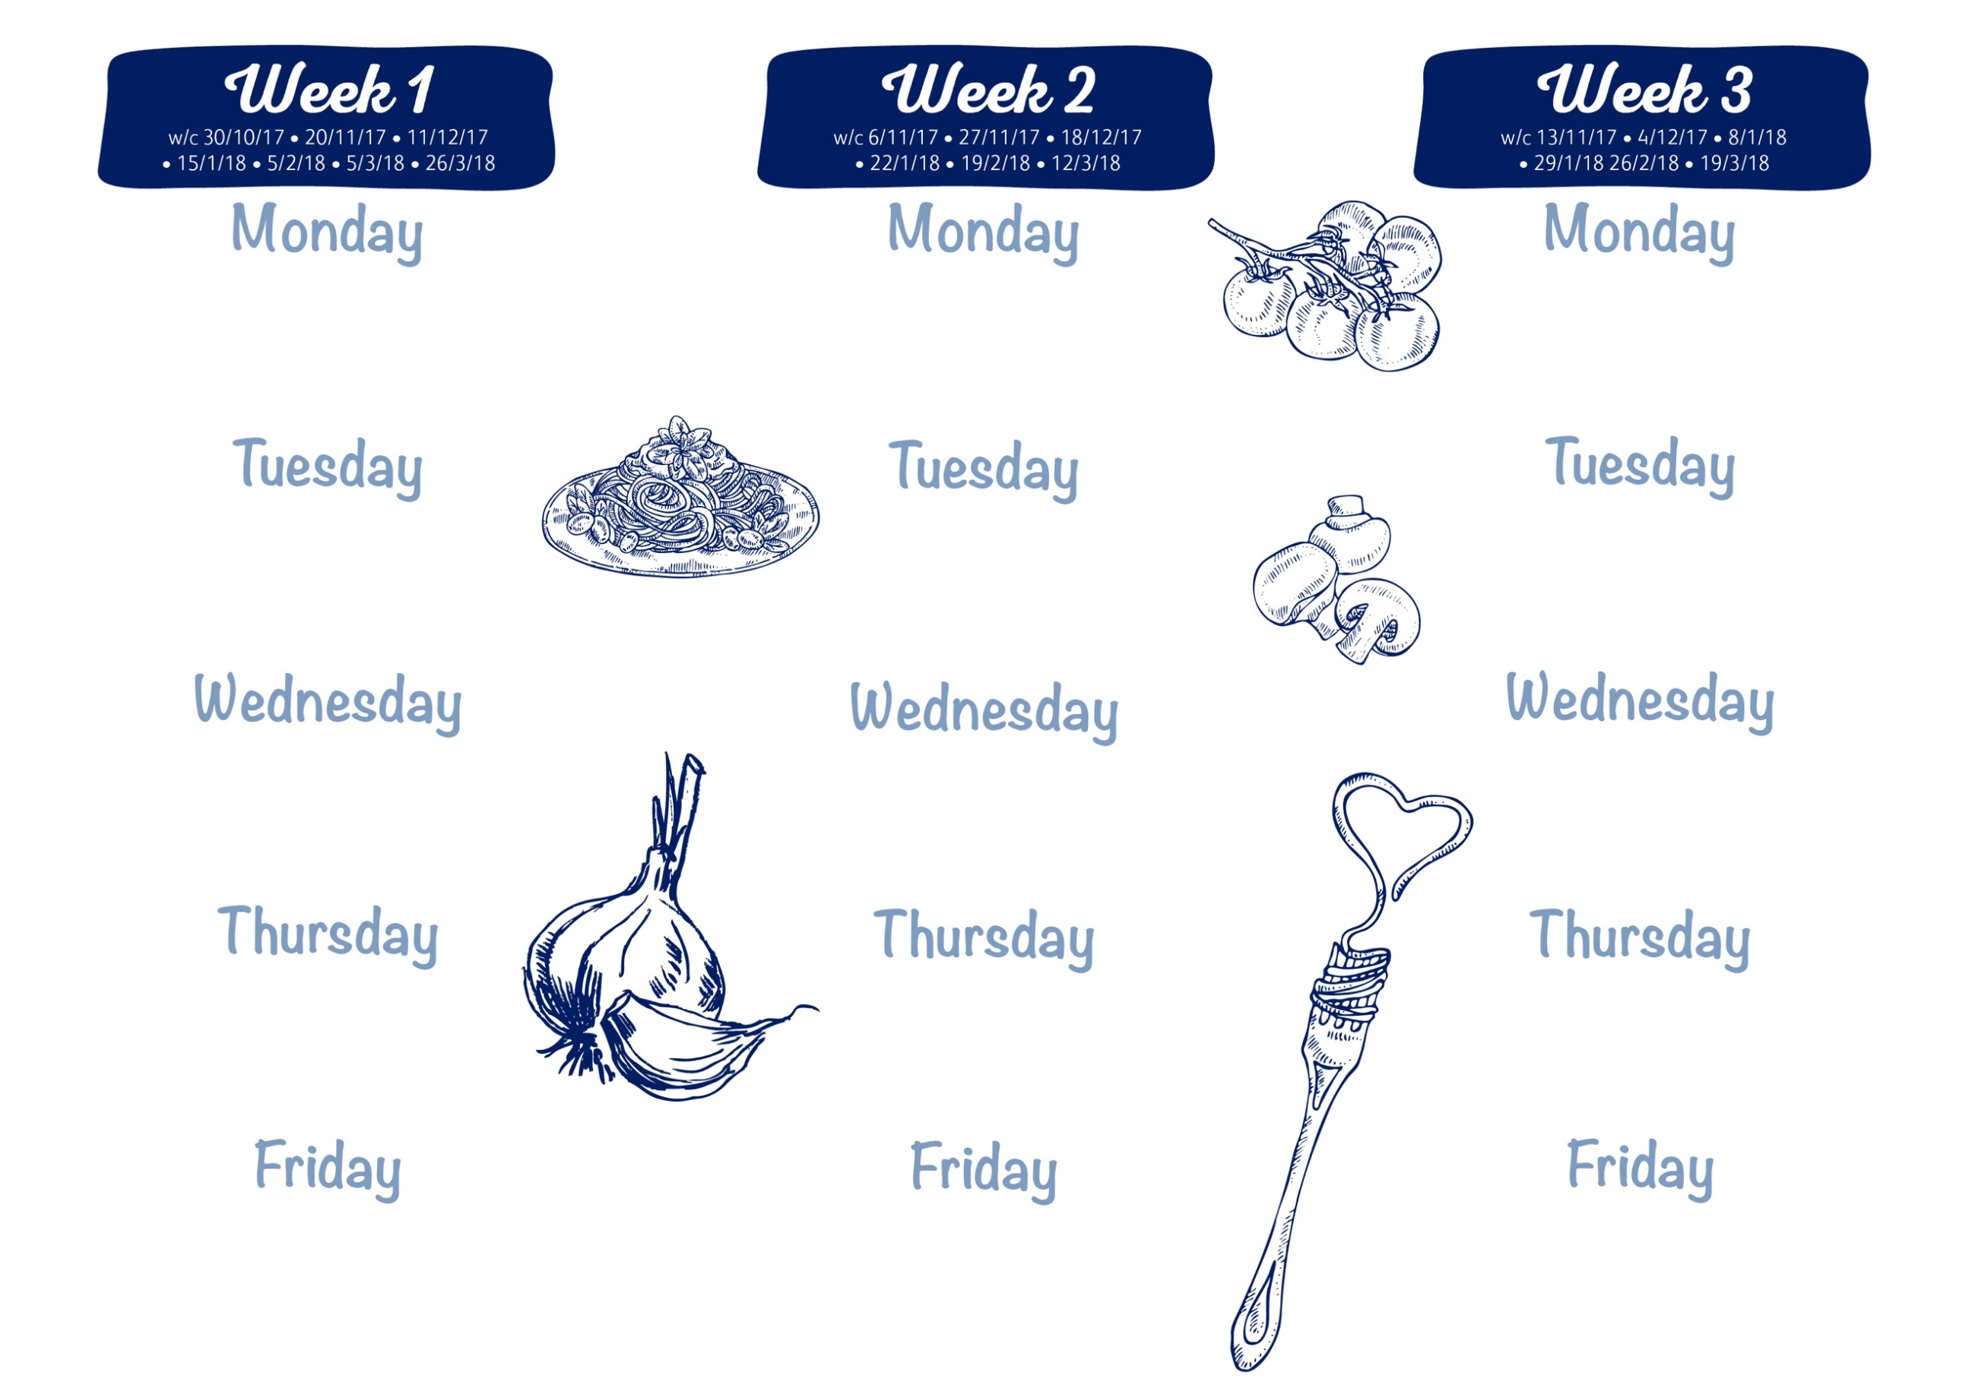

Chicken Curry, Naan Bread

Vegetable Fingers or Quorn Nuggets (v)

Jacket Potato/ Sandwich

50:50 Rice, Seasonal Vegetables

Mini Doughnuts, Yoghurt Dip

Beef Burger & Gravy

Sweet Potato Fishcake

Jacket Potato/ Sandwich

Duchess Potatoes; Seasonal Vegetables

Cheese & Crackers/ Fruit Yoghurt

Chicken with BBQ Sauce and cheddar

Sausage Roll (v)

Jacket Potato/ Sandwich

Potato Rosti/Waffle; Seasonal Vegetables

Cook’s Cookie of the Day

Chicken/Steak Pie

Cheese (v) or Tuna Melt Panini

Jacket Potato/ Sandwich

Mashed Potato; Seasonal Vegetables

Sticky Toffee Pudding, Toffee custard

Roasted Pork Loin & Gravy

Tomato & Basil Spaghetti (v)

Jacket Potato/ Sandwich

Roast Potatoes; Seasonal Vegetables

Fruit Jelly

Pork Meatballs & Gravy

Cheddar Cheese & Onion Quiche (v)

Jacket Potato/ Sandwich

Mashed Potato; Seasonal Vegetables

Chocolate Surprise Cake

Breaded Chicken Bites

Quorn & Vegetable Curry (v)

Jacket Potato/ Sandwich

50:50 Rice; Herby Diced Potatoes

Vanilla Raspberry Ripple Ice Cream

Roast Chicken, stuffing & Gravy

Veg & Potato Puff Pastry Pie (v)

Jacket Potato/ Sandwich

Roast Potatoes; Seasonal Vegetables

Home-made Gingerbread biscuit

Cottage Pie

Cheese & Tomato Pasta Bake (v)

Jacket Potato/ Sandwich

Seasonal Vegetables

Cook’s Fruit Crumble & custard

Battered Fish

Home-made pizza (v)

Sandwich or Wrap

Chips; Peas; Sweetcorn

Fresh fruit salad & Ice Cream

Battered Fish

Home-made pizza (v)

Sandwich or Wrap

Chips; Peas; Sweetcorn

Vanilla Ice Cream

Battered Fish

Home-made pizza (v)

Sandwich or Wrap

Chips; Peas; Sweetcorn

Fresh fruit salad & Ice Cream

Spaghetti Bolognese, garlic bread

Quorn burger on a bun (v)

Jacket Potato/ Sandwich

Seasonal Vegetables

Blueberry Cake

W/C: 29/10/18; 19/11/18; 10/12/18; 14/1/19; 4/2/19; 4/3/19; 25/3/19.

Roast Beef, Yorkshire Pudding, Gravy

Macaroni Cheese (v)

Jacket Potato/ Sandwich

Roast Potatoes; Seasonal Vegetables

Fruit Flapjack

Sausages & Onion Gravy

Cheese & Tomato Quesadilla (v)

Jacket Potato/ Sandwich

Mashed Potato; Seasonal Vegetables

Cook’s Fruit Muffin

Dates: 12/11/18; 3/12/18; 7/1/19; 28/1/19; 25/2/19; 18/3/19.

Dates : 5/11/18; 26/11/18; 17/12/18; 21/1/19; 11/2/19; 11/3/19; 1/4/19.